MAP ASSIGNMENT-4
1) Creating Success and Error Response Settings for HTTP Listeners in a Mule Application
Understanding Error Response Settings
In Mule applications, Error Response Settings determine how the system reacts when something goes wrong in a flow.
Instead of displaying a default or vague error, you can set up Mule to send a specific HTTP response — including the status code, message, and payload — back to the client.
Example:
If an invalid input is sent by a client, you can configure Mule to return a 400 Bad Request with a descriptive message explaining the issue.

Steps to Configure Success and Error Responses
Step 1: Add an HTTP Listener
- Drag an HTTP Listener component to the flow.
- Path: /err
- Purpose: Receives incoming requests at the /err endpoint.

Step 2: Add a Set Variable Component
- Place a Set Variable right after the listener.
- Name: name
- Value: abc
- Purpose: Stores a variable value that can be reused later in the flow.

Step 3: Add an HTTP Request Component
- Add an HTTP Request element after setting the variable.
- URL: xyzabc.com
- Method: GET
- Body: payload
- Purpose: Sends the received request data to an external API.

Step 4: Add a Transform Message for Successful Responses
- Insert a Transform Message component.
- Purpose: Defines the success message (e.g., returning "success") if the API call is successful.
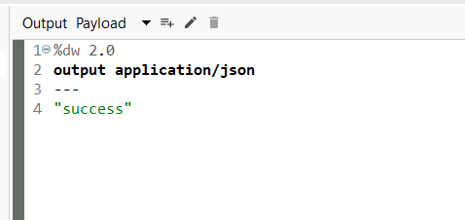

Step 5: Configure Error Handling
- Open the Error Handling section in the flow.
- Add an On Error Continue block.
- Error Types: HTTP:CONNECTIVITY, HTTP:UNAUTHORIZED
- Purpose: Captures connection or authentication errors and allows the flow to proceed instead of failing completely.

Step 6: Add Transform Message for Error Response
- Inside the error handler, add another Transform Message component.
- Purpose: Returns a custom message like "continue error" when connection or authorization problems occur.
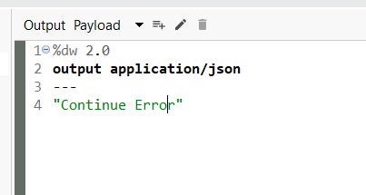
Step 7: Add a Logger
- Place a Logger after the error message transformation.
- Message: #[payload]
- Purpose: Logs the custom error message in the Anypoint Studio console.
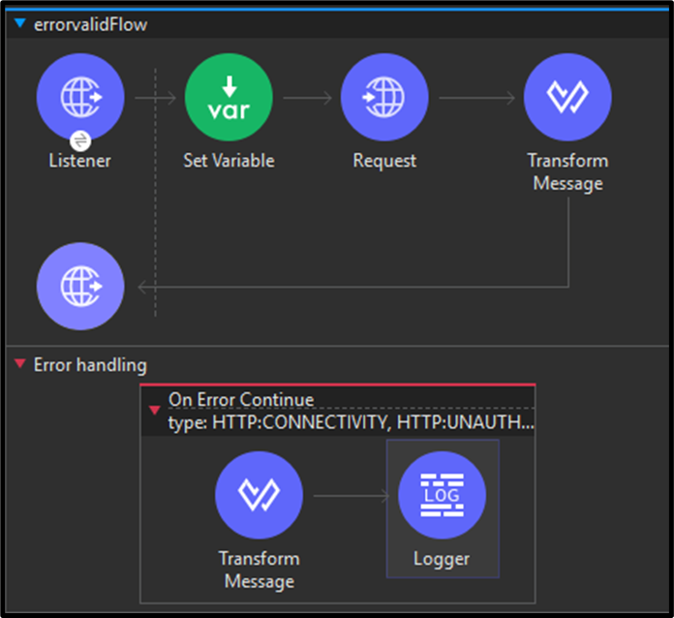

Step 8: Test the Flow
Run the Mule app and test using Postman or another REST client.
- Method: POST or GET
- URL: http://localhost:8081/err
- Sample Body:
{
"id": 1,
"name": "test"
}
Expected Output:
- If the external API works: "success"
- If the API fails or is unauthorized: "continue error"
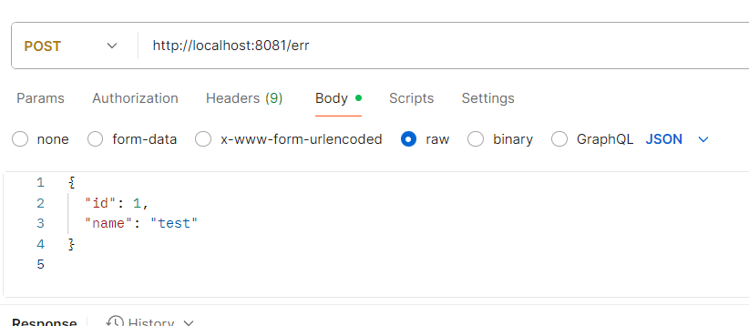
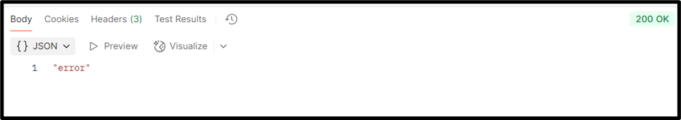
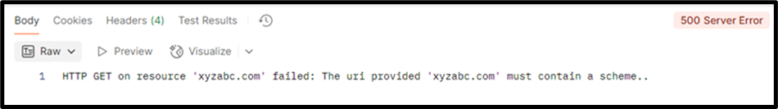
2) DataWeave Selectors
DataWeave selectors help navigate objects and arrays to extract values that match certain keys or positions. They always operate relative to a context — this can be a variable, an object, an array, or the output of another function.
Selector Type | Syntax | Description | Output Type
Single-value | .keyName | Retrieves the value of a specific key | Value
Multi-value | .*keyName | Returns all values matching a key | Array
Descendants | ..keyName | Returns all nested key matches | Array
Index | [index] | Retrieves an element at a specific array position | Value
Range | [start to end] | Returns multiple values in a specified range | Array

Single-Value Selector
Example:
Input:
{
"name": "Ana",
"age": 29
}
DataWeave Script:
%dw 2.0
output json
---
payload.age
Output:
29
You can also use square brackets for dynamic key references:
%dw 2.0
output json
---
{
fixed: payload.age,
dynamic: payload[payload.dynamicKey]
}

Index Selector
Used for accessing elements in an array:
%dw 2.0
output json
---
payload[1]
Input: ["prod", "qa", "dev"]
Output: "qa"
Negative indexes count from the end, e.g., payload[-1] gives the last element.

Range Selector
Used to fetch a range of elements:
%dw 2.0
output json
---
payload[0 to 1]
Output: ["prod", "qa"]

Multi-Value Selector
Fetches all values for a key that appears multiple times:
%dw 2.0
output json
---
payload.*name
Output: ["Emilia", "Isobel", "Euphemia", "Rose"]

Descendants Selector
Retrieves all values of a key regardless of their depth in the data structure:
%dw 2.0
output json
---
payload..echo
Output:
[{ "value": "Hello there!"}, "Getting details...", "Success!"]

3) DataWeave Functions
Functions in DataWeave let you encapsulate logic for reuse. They can be named or anonymous (lambdas) and are crucial for modular scripts.

Named Functions
A named function is declared with the fun keyword:
fun add(a, b) = a + b
---
add(1, 2)
Output: 3
Lambda Functions
Anonymous functions without names, written as:
(x, y) -> x + y
They are useful when passed as arguments or returned from other functions.

Higher-Order Functions
Functions that accept other functions as arguments or return them.
Example using filter:
%dw 2.0
output json
fun isOdd(n) = (n mod 2) == 1
var numbers = (1 to 5)
---
filter(numbers, (n) -> isOdd(n))
Output: [1, 3, 5]

Infix Notation
A concise way to call two-argument functions:
%dw 2.0
output json
var numbers = (1 to 5)
---
numbers filter ((n) -> (n mod 2) == 1)

Syntax
Special placeholders simplify lambda expressions:
%dw 2.0
output json
var numbers = (1 to 5)
---
numbers filter ($ mod 2 == 1)
Output: [1, 3, 5]
These can also be chained to access object properties:
payload filter $.price > 5
Output:
[
{ "id": 2, "item": "steak", "price": 15.00 }
]

